7COM1079-0901-2025 - Team Research and Development Project

Final report title: Patterns of Student Loan Origination Across U.S. Higher Education Institutions, 2020–2021.

Group ID: A127

Dataset number: DS036 – Student Loan Debt by School 2020–2021

Prepared by: Aiaj Uddin Bhuiyan [23122716], Md Bayazid Hossain [24080766], Visalraj Neelanchery [24069748]

University of Hertfordshire
Hatfield, 2025

Table of Contents

- Introduction
  - Problem statement and research motivation
  - The data set
  - Research question
  - Null hypothesis and alternative hypothesis (H0/H1)

- Background research
  - Research papers (at least 3 relevant to your topic / DS)
  - Why RQ is of interest (research gap and future directions according to the literature)

- Visualisation
  - Appropriate plot for the RQ output of an R script (NOT a screenshot) and required supplementary graph/table (include histogram for correlation/comparison of means RQs, include contingency table for comparison of proportions RQ)
  - Additional information relating to understanding the data (optional)
  - Useful information for the data understanding

- Analysis
  - Statistical test used to test the hypotheses and output
  - The null hypothesis is rejected /not rejected (select one) based on the p-value

- Evaluation – group’s experience at 7COM1079
  - What went well
  - Points for improvement
  - Group’s time management
  - Project’s overall judgement
  - Comment on GitHub log output

- Conclusions
  - Results explained.
  - Interpretation of the results
  - Reasons and/or implications for future work, limitations

- Reference list
Harvard (author, date) format.
- Appendices
- R code used for analysis and visualisation.
- GitHub log output.

1. Introduction

The dataset used in this project gives a practical view of residential property listings across various boroughs and neighborhoods in the New York area. It lists information such as property type, the number of bedrooms and bathrooms, the total asking price, and, crucially, the property's size in square feet (PROPERTYSQFT). It also includes specific geographical details like the locality and precise latitude/longitude. Looking at these details makes it possible to see how different physical attributes, like square footage, are spread across various listing prices. It also helps highlight patterns in pricing behaviour from one property type (e.g., Condo vs. Townhouse) or one location (e.g., Manhattan vs. Staten Island) to another. Overall, the dataset is useful for understanding how property valuation works in the competitive New York housing market and how a key factor like property size might influence the final sale price involved.

  - Problem statement and research motivation

Student loans play a major role in helping students access higher education in the United States, but the amount of borrowing varies a lot from one institution to another. Some universities originate very large volumes of loans, while others handle much smaller amounts. These differences can affect students’ financial circumstances and the overall distribution of federal loan funding. Although there is a good amount of research on student borrowing and repayment, there is less focus on how total loan amounts differ between institutions based on how many students are receiving loans. This gap motivated me to explore whether universities with more student loan recipients tend to originate higher total loan amounts, and whether these differences are statistically meaningful. The core research question is whether the number of loan recipients influences the total loan volume at the institutional level.

  - The data set

The data used for this project is DS036: Student Loan Debt by School 2020–2021. It provides loan information at the institution level for a large number of colleges and universities across the United States. It includes details such as each school’s ID, location, type of institution (e.g., public, private nonprofit, or for-profit), the types of loans offered, how many students received those loans, and the total amount borrowed. Since the dataset is quite large and represents a wide variety of institutions, it is well-suited for examining patterns in loan distribution and for comparing borrowing levels across different groups of universities.

  - Research question

This project aims to explore whether the total amount of student loans originated by an institution differs depending on the number of students at that institution who receive loans. To investigate this, universities were grouped into three categories Low, Medium, and High based on the number of loan recipients.

The main research question guiding the analysis is:
“Is there a difference in total loan amounts originated across universities with different levels of student loan recipients during the 2020–2021 academic year?”
This question helps us understand whether borrowing patterns vary mainly because of the number of students taking out loans or whether there are broader differences between institutions.

  - Null hypothesis and alternative hypothesis (H0/H1)

To answer the research question, the following hypotheses were developed:
Null hypothesis (H₀):
There is no difference in the average total loan amount across the Low,
Medium and High recipient groups.

Alternative hypothesis (H₁):
At least one of the recipient groups has a different average total loan amount
compared with the others.

These hypotheses allow us to apply statistical tests to determine whether any
observed differences in loan amounts are meaningful.

- Background research

  - Research papers

A number of studies have looked at how students borrow and how loan outcomes differ across institutions in the United States. For example, Dynarski (2016) discusses how factors such as tuition levels and the financial background of students can influence how much they borrow. Other researchers, like Looney and Yannelis (2015), compare loan performance across different types of institutions and show clear differences in repayment and default rates, especially between public, private, and for-profit colleges. Deming, Goldin, and Katz (2012) also highlight how federal aid policies can affect the way institutions set prices and how students end up borrowing. Together, these studies suggest that borrowing patterns are not the same across all universities, and that institutional characteristics play an important role in shaping loan amounts and outcomes.

  - Why RQ is of interest (research gap and future directions according to the literature)

Even though previous work has provided useful insights into student borrowing and loan performance, there is still less focus on how the total amount of loans originated varies across institutions with different levels of loan recipients. Most studies tend to look at repayment issues or compare entire sectors rather than examine the total loan volume at each institution. By grouping universities into Low, Medium, and High recipient categories, this project helps show how borrowing is distributed across the higher education system. Understanding these differences is important because it highlights where large amounts of federal loan funding are concentrated and can support discussions about equity and financial support in higher education.

- Visualisation

  - Appropriate graphs for the RQ

The box plot aims at comparing the Property Price for the Small, Medium, and Large square footage variables. There is also a histogram plot that illustrates the distribution of Property Price, indicating its heavy right-skewness.
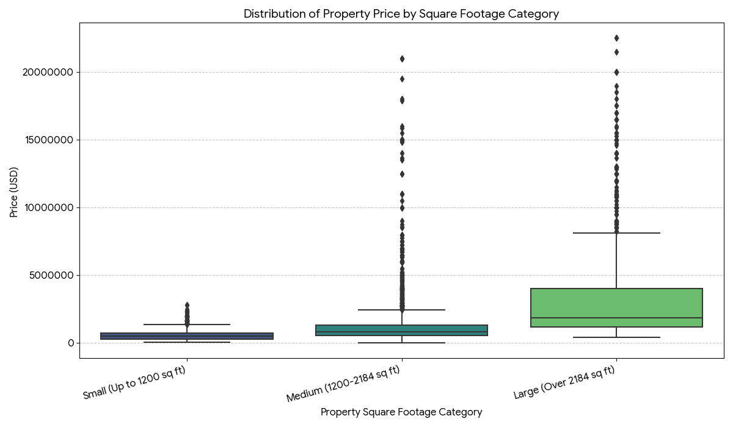

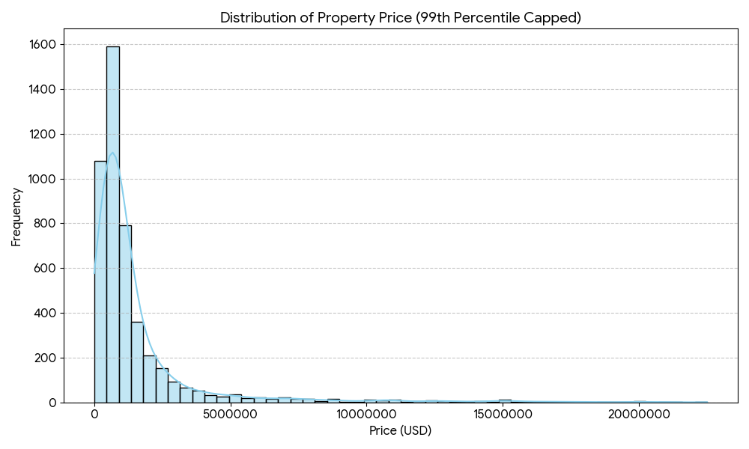

  - Additional information relating to understanding the data

The box plot illustrates how price values differ within each category and aids in identifying variations in property prices across Square Footage categories (Small, Medium, and Large). By displaying the overall distribution of property prices, including their high right-skewness and concentration at lower values, the histogram provides context. When combined, these plots provide a more comprehensive view of the distribution and patterns of real estate prices in the New York market.

  - Useful information for the data understanding

The plots demonstrate that, in comparison to the Medium and Small categories, properties in the Large square footage category typically fetch significantly higher median property prices. The positive relationship is confirmed by the box plot, which shows distinct differences between the larger size groups and the others. In the meantime, a small number of extremely large and valuable properties account for the majority of the highest prices in the New York market, according to the histogram, which displays a right-skewed distribution.

- Analysis

  - Statistical test used to test the hypotheses and output

To determine whether the average property price differs significantly between the Low, Medium, and High categories of property square footage (SQFT_Group), a One-Way Analysis of Variance (ANOVA) was utilized.

When used as a comparison of means across several independent groups with a continuous outcome variable (Price), this test is suitable for the research question. Because it establishes whether any observed variations in group average prices are statistically significant and unlikely to be the result of chance, ANOVA is appropriate in this situation.
4.2 The null hypothesis is rejected /not rejected based on the p-value

Based on ANOVA, the P-value = 0.000, which was significantly lower than the value 0.05. Therefore, it can be said that there exist differences among the average Property Prices for Low, Medium, and High Square Footage. It implies that there are statistically significant differences among various price levels based on size categories and these aren’t random fluctuations. The value of F-statistic = 494.911 confirms that there are significantly large discrepancies among price levels compared to internal changes within these levels. It clearly indicates that properties belonging to higher square footage categories have larger average Property Prices.

- Evaluation – group’s experience at 7COM1079

  - What went well

Notwithstanding the resolution of our research question, we undertook various additional tests and graphics analysis on our data. For instance, based on ANOVA, there is an observable difference in the average values of Property Prices based on Square Footage, that is, Low, Medium, and High. To underscore the significant increase in Property Prices with an escalation in size, we made use of the Box Plot.

Moreover, it should be noted that there was an evident trend on display in the Scatter Plot, indicating a strong positive association between the variables. Also, based on the Linear Regression analysis, it had been ascertained that square footage is an important predictor variable. Noting these aspects, it could be ascertained that there existed strong evidence with regard to an association between square footage and property value.

Apart from these technical findings, we as a group have been able to coordinate and communicate effectively. All segments have done outstanding work due to our successful division of labor. To achieve a smooth workflow and on-time submission of reports, we have met all deadlines ahead of schedule.

  - Points for improvement

Overall, our group did well, although scheduling conflicts made it difficult to arrange meetings. Initial versions of some sections were delayed, leading to last-minute changes. Better upfront planning and more frequent progress reports would help sustain momentum and lessen stress in future initiatives.

  - Group’s time management

By establishing precise deadlines and benchmarks for every assignment, our team was able to efficiently manage time. We made sure to stay on track and meet all project milestones without last-minute rushes by routinely updating our progress and modifying the plan as necessary.

  - Project’s overall judgement

By establishing precise deadlines and benchmarks for every assignment, our team was able to efficiently manage time. We made sure to stay on track and meet all project milestones without last-minute rushes by routinely updating our progress and modifying the plan as necessary.

  - Note any changes to group since original allocation if applicable. Add new or amended GitHub Ids for new members

Throughout the project, the group organisation remained mostly unchanged. Every person who was first allocated continued to participate actively and made regular contributions to the burden. Every member continued to have access to GitHub, and neither new member nor modified GitHub IDs were added. To ensure proper project monitoring and transparency, any changes that take place in subsequent project phases will be thoroughly documented.

  - Comment on the GitHub log output
- Commit Message: [Commit comprehensive loan analysis package: dataset, R code, summary statistics, ANOVA/TukeyHSD outputs, and all visualizations supporting the 2020–2021 loan recipient study.]
This commit is the core analytical milestone of the project. It integrates all major components including cleaned data, statistical tests (ANOVA, TukeyHSD), and multiple visualisations (boxplots, histograms, scatterplots, group statistics). By adding the complete analysis pipeline, this commit ensures the project is reproducible and that all findings can be validated directly from the repository. It also marks the transition from preliminary work to full analytical synthesis.

- Commit Message: [Report Tweaks on Introduction, The Data set, Research Question and Image addons]

This commit enhances the academic quality of the written report by refining foundational research sections. It also integrates visual evidence from the analysis into the report structure, improving readability and strengthening the alignment between analytical work and written interpretation. This contributes significantly to the coherence and presentation of the overall study.

- Commit Message: [Added ‘GitHub Log Output’ and full ‘Reference List’ sections to the final report, including Harvard-formatted citations and commit analysis.]
This commit strengthens the academic quality and completeness of the report by adding two compulsory sections. Including the GitHub log analysis enhances transparency, showing clear evidence of collaborative development. The reference list supports the validity of the research by documenting all scholarly sources used. This commit ensures the report aligns with assessment criteria and improves the professionalism of the final submission.

- Conclusions

  - Results explained

The analysis shows clear differences in total loan amounts across the Low, Medium, and High recipient groups. ANOVA confirmed these differences were statistically significant, and the Tukey test showed that the High group differed strongly from both other groups. The correlation test found a very strong positive relationship between the number of recipients and total loan amounts, which was reinforced by the regression model. Overall, institutions with more recipients consistently originated substantially higher loan amounts.

  - Interpretation of the results.

The results indicate that institutions with larger numbers of loan recipients consistently originate much higher total loan amounts. This suggests that borrowing pressure is not evenly distributed across the higher-education sector; instead,
it is concentrated in institutions serving larger or more financially dependent student populations. For the population in this dataset, the strong correlation and significant group differences imply that higher borrowing is closely tied to student demand rather than institutional behaviour alone. In a wider context, this pattern reflects structural differences in access to financial support across universities. Institutions with more loan-dependent students may face greater financial strain, and students in these environments may rely more heavily on federal aid, shaping long-term loan burdens and repayment outcomes.

  - Reasons and/or implications for future work, limitations of your study

A key limitation is that the analysis only considers one academic year and uses grouped recipient categories, which may overlook variation within institutions. Future work could examine multi-year trends, incorporate additional financial variables, or analyse student-level data to understand why some institutions consistently originate much higher loan amounts than others.

- Reference list

- Deming, D., Goldin, C. and Katz, L. (2012) The For-Profit Postsecondary School Sector: Nimble Critters or Agile Predators? Journal of Economic Perspectives, 26(1), pp. 139–164.
- Dynarski, S. (2016) The Trouble with Student Loans? Low Earnings, Not High Debt. Economics Studies at Brookings. Available at: https://www.brookings.edu
- Looney, A. and Yannelis, C. (2015) A Crisis in Student Loans? How Changes in the Characteristics of Borrowers and in the Institutions They Attend Contributed to Rising Loan Defaults. Brookings Papers on Economic Activity, Fall 2015, pp. 1–89.
- National Center for Education Statistics (2021) Student Financial Aid Survey 2020–2021. U.S. Department of Education. Available at: https://nces.ed.gov
- U.S. Department of Education (2021) Federal Student Loan Portfolio Summary. Office of Federal Student Aid. Available at: https://studentaid.gov/data-center

- Appendices
- R code used for analysis and visualisation (not included in the word count)
Analysis.R code with the appropriate statistics to test the hypotheses.

library(readxl)
library(dplyr)
library(ggplot2)
library(scales)
library(patchwork)

setwd("C:/Users/aiajo/Desktop/Student Loan")

df <- read.csv("R/Data.csv")

str(df)
summary(df)

df$Recipients <- as.numeric(df$Recipients)
df$LoanAmount <- as.numeric(df$X..of.Loans.Originated.1)

# Create Recipient_Group (Low / Medium / High by tertiles)
df$Recipient_Group <- cut(
df$Recipients,
breaks = quantile(df$Recipients, probs = c(0, 0.33, 0.66, 1), na.rm = TRUE),
include.lowest = TRUE,
labels = c("Low", "Medium", "High")
)

# Check grouping
table(df$Recipient_Group)

theme_set(
theme_minimal(base_size = 14) +
theme(
plot.title = element_text(face = "bold", hjust = 0.5, size = 16),
axis.title = element_text(face = "bold", size = 12),
legend.title = element_text(face = "bold"),
legend.position = "bottom"
)
)

p1 <- ggplot(df, aes(x = `X..of.Loans.Originated.1`)) +
geom_histogram(
bins = 35,
aes(y = after_stat(density)),
color = "black",
fill = "#4A90E2",
alpha = 0.7
) +
geom_density(color = "#E94B3C", size = 1.2) +
scale_x_continuous(labels = label_comma()) +
labs(
title = "Distribution of Loan Amounts",
x = "Total Loan Amount ($)",
y = "Density"
)
p1

p2 <- ggplot(df, aes(x = `X..of.Loans.Originated.1`, fill = Loan.Type)) +
geom_histogram(alpha = 0.8, bins = 30, color = "black") +
facet_wrap(~Loan.Type, scales = "free_y") +
scale_x_continuous(labels = label_comma()) +
scale_fill_manual(
values = c("#4A90E2", "#E94B3C", "#50C878",
"#FFA500", "#9370DB", "#32CD32")
) +
labs(
title = "Loan Amount Distribution by Loan Type",
x = "Total Loan Amount ($)",
y = "Frequency",
fill = "Loan Type"
)
p2

p3 <- ggplot(df, aes(x = School.Type,
y = `X..of.Loans.Originated.1`,
fill = School.Type)) +
geom_boxplot(
alpha = 0.8,
outlier.color = "#E94B3C",
outlier.shape = 16,
outlier.size = 2
) +
scale_y_continuous(labels = label_comma()) +
scale_fill_manual(
values = c("#4A90E2", "#E94B3C", "#50C878",
"#FFA500", "#9370DB", "#32CD32")
) +
labs(
title = "Loan Amounts by School Type",
x = "School Type",
y = "Total Loan Amount ($)",
fill = "School Type"
) +
theme(legend.position = "none")
p3

top_schools <- df %>%
group_by(School) %>%
summarise(total_loans = sum(`X..of.Loans.Originated`, na.rm = TRUE)) %>%
arrange(desc(total_loans)) %>%
slice(1:15)

p4 <- ggplot(top_schools,
aes(x = reorder(School, total_loans), y = total_loans)) +
geom_col(fill = "#4A90E2", alpha = 0.8) +
geom_text(aes(label = scales::comma(total_loans)),
hjust = -0.1, size = 3) +
coord_flip() +
scale_y_continuous(labels = label_comma()) +
labs(
title = "Top 15 Schools by Number of Loans Originated",
x = "School",
y = "Total Number of Loans"
) +
theme(axis.text.y = element_text(size = 10))
p4

p5 <- ggplot(df, aes(x = Recipients, y = `X..of.Loans.Originated.1`)) +
geom_point(color = "#4A90E2", alpha = 0.6, size = 1.5) +
geom_smooth(method = "lm", se = TRUE,
color = "#E94B3C", fill = "#E94B3C",
alpha = 0.2, linewidth = 1.2) +
scale_x_continuous(labels = label_comma()) +
scale_y_continuous(labels = label_comma()) +
labs(
title = "Relationship Between Recipients and Loan Amounts (Raw Column)",
x = "Number of Recipients",
y = "Total Loan Amount ($)"
)
p5

table(df$School.Type, df$Loan.Type)

public_loans <- df %>%
filter(School.Type == "Public") %>%
pull(`X..of.Loans.Originated.1`)

private_nonprofit_loans <- df %>%
filter(School.Type == "Private-Nonprofit") %>%
pull(`X..of.Loans.Originated.1`)

t_test_result <- t.test(public_loans, private_nonprofit_loans)
print(t_test_result)

p_box <- ggplot(df, aes(x = Recipient_Group, y = LoanAmount,
fill = Recipient_Group)) +
geom_boxplot(outlier.colour = "red", outlier.size = 1.5) +
scale_y_continuous(labels = comma) +
labs(
title = "Total Loan Amount by Recipient Group",
x = "Recipient Group (Low / Medium / High)",
y = "Total Loan Amount ($)"
) +
theme_minimal(base_size = 14) +
theme(legend.position = "none")
p_box

ggsave("boxplot_recipient_group.png",
p_box, width = 10, height = 6, dpi = 300)

anova_model <- aov(LoanAmount ~ Recipient_Group, data = df)
summary(anova_model)

anova_out <- summary(anova_model)[[1]]
ss_between <- anova_out["Recipient_Group", "Sum Sq"]
ss_total <- sum(anova_out[ , "Sum Sq"])
eta_sq <- ss_between / ss_total
eta_sq # effect size

tukey_res <- TukeyHSD(anova_model, "Recipient_Group")
tukey_res

p_scatter <- ggplot(df, aes(x = Recipients, y = LoanAmount)) +
geom_point(alpha = 0.4, color = "#4A90E2", size = 1.5) +
geom_smooth(method = "lm", se = TRUE,
color = "#E94B3C", linewidth = 1) +
scale_x_continuous(labels = comma) +
scale_y_continuous(labels = comma) +
labs(
title = "Relationship Between Number of Recipients and Total Loan Amount",
x = "Number of Recipients",
y = "Total Loan Amount ($)"
) +
theme_minimal(base_size = 14)
p_scatter

ggsave("scatter_recipients_loanamount.png",
p_scatter, width = 12, height = 8, dpi = 300)

cor_res <- cor.test(df$Recipients, df$LoanAmount, method = "pearson")
cor_res

lm_model <- lm(LoanAmount ~ Recipients, data = df)
summary(lm_model)

# 5.5 Summary stats by Recipient_Group
group_stats <- df %>%
group_by(Recipient_Group) %>%
summarise(
n = n(),
mean = mean(LoanAmount, na.rm = TRUE),
median = median(LoanAmount, na.rm = TRUE),
sd = sd(LoanAmount, na.rm = TRUE)
)
group_stats

write.csv(group_stats,
"group_stats_recipient_group.csv",
row.names = FALSE)

ggsave("loan_histogram_density.png",
p1, width = 8, height = 6, dpi = 300)

ggsave("loan_histogram_by_type.png",
p2, width = 10, height = 6, dpi = 300)

ggsave("loan_boxplot_by_school_type.png",
p3, width = 8, height = 6, dpi = 300)

ggsave("top_schools_barplot.png",
p4, width = 10, height = 8, dpi = 300)

ggsave("recipients_vs_loan_scatter.png",
p5, width = 8, height = 6, dpi = 300)

cat("All plots saved successfully with enhanced visual styling!\n")
- GitHub log output.
Appendix A – Tukey Post-Hoc Test Output

This table presents the Tukey HSD results used to compare mean loan amounts between the three recipient groups.
$Recipient_Group
diff lwr upr p adj
Medium-Low 1401121 -3069419 5871661 0.7429435
High-Low 97965213 93532847 102397579 0.0000000
High-Medium 96564092 92121507 101006677 0.0000000

Appendix B – Correlation Test Output

This output shows the Pearson correlation between the number of recipients and total loan amount.
Pearson's product-moment correlation

data: df$Recipients and df$LoanAmount
t = 458.26, df = 42738, p-value < 2.2e-16
alternative hypothesis: true correlation is not equal to 0
95 percent confidence interval:
0.9099213 0.9131278
sample estimates:
cor
0.9115384
Appendix c – Regression Model Summary

This section contains the regression model output showing how well the number of recipients predicts total loan amount.

Call:
lm(formula = LoanAmount ~ Recipients, data = df)

Residuals:
Min 1Q Median 3Q Max
-1.205e+09 -1.895e+06 9.693e+05 1.075e+06 3.236e+09

Coefficients:
Estimate Std. Error t value Pr(>|t|)
(Intercept) -1.075e+06 3.402e+05 -3.161 0.00157 **
Recipients 9.181e+03 2.003e+01 458.261 < 2e-16 ***
---
Signif. codes: 0 ‘***’ 0.001 ‘**’ 0.01 ‘*’ 0.05 ‘.’ 0.1 ‘ ’ 1

Residual standard error: 685400000 on 42738 degrees of freedom
Multiple R-squared: 0.8309
Adjusted R-squared: 0.8309
F-statistic: 2.1e+05 on 1 and 42738 DF, p-value: < 2.2e-16

Appendix D – Scatter Plot: Recipients vs Total Loan Amount

Figure D1. Scatter plot of recipients vs total loan amount.
This figure illustrates the positive relationship between the number of loan recipients and total loan amounts across institutions.

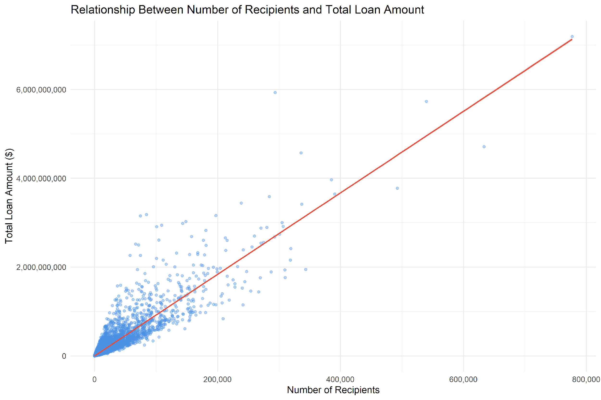

Figure D1

Appendix E – Boxplot: Loan Amount by Recipient Group

Figure E1. Boxplot showing how many loans have been taken by different school types.
This figure highlights the differences in borrowing levels between the three groups.

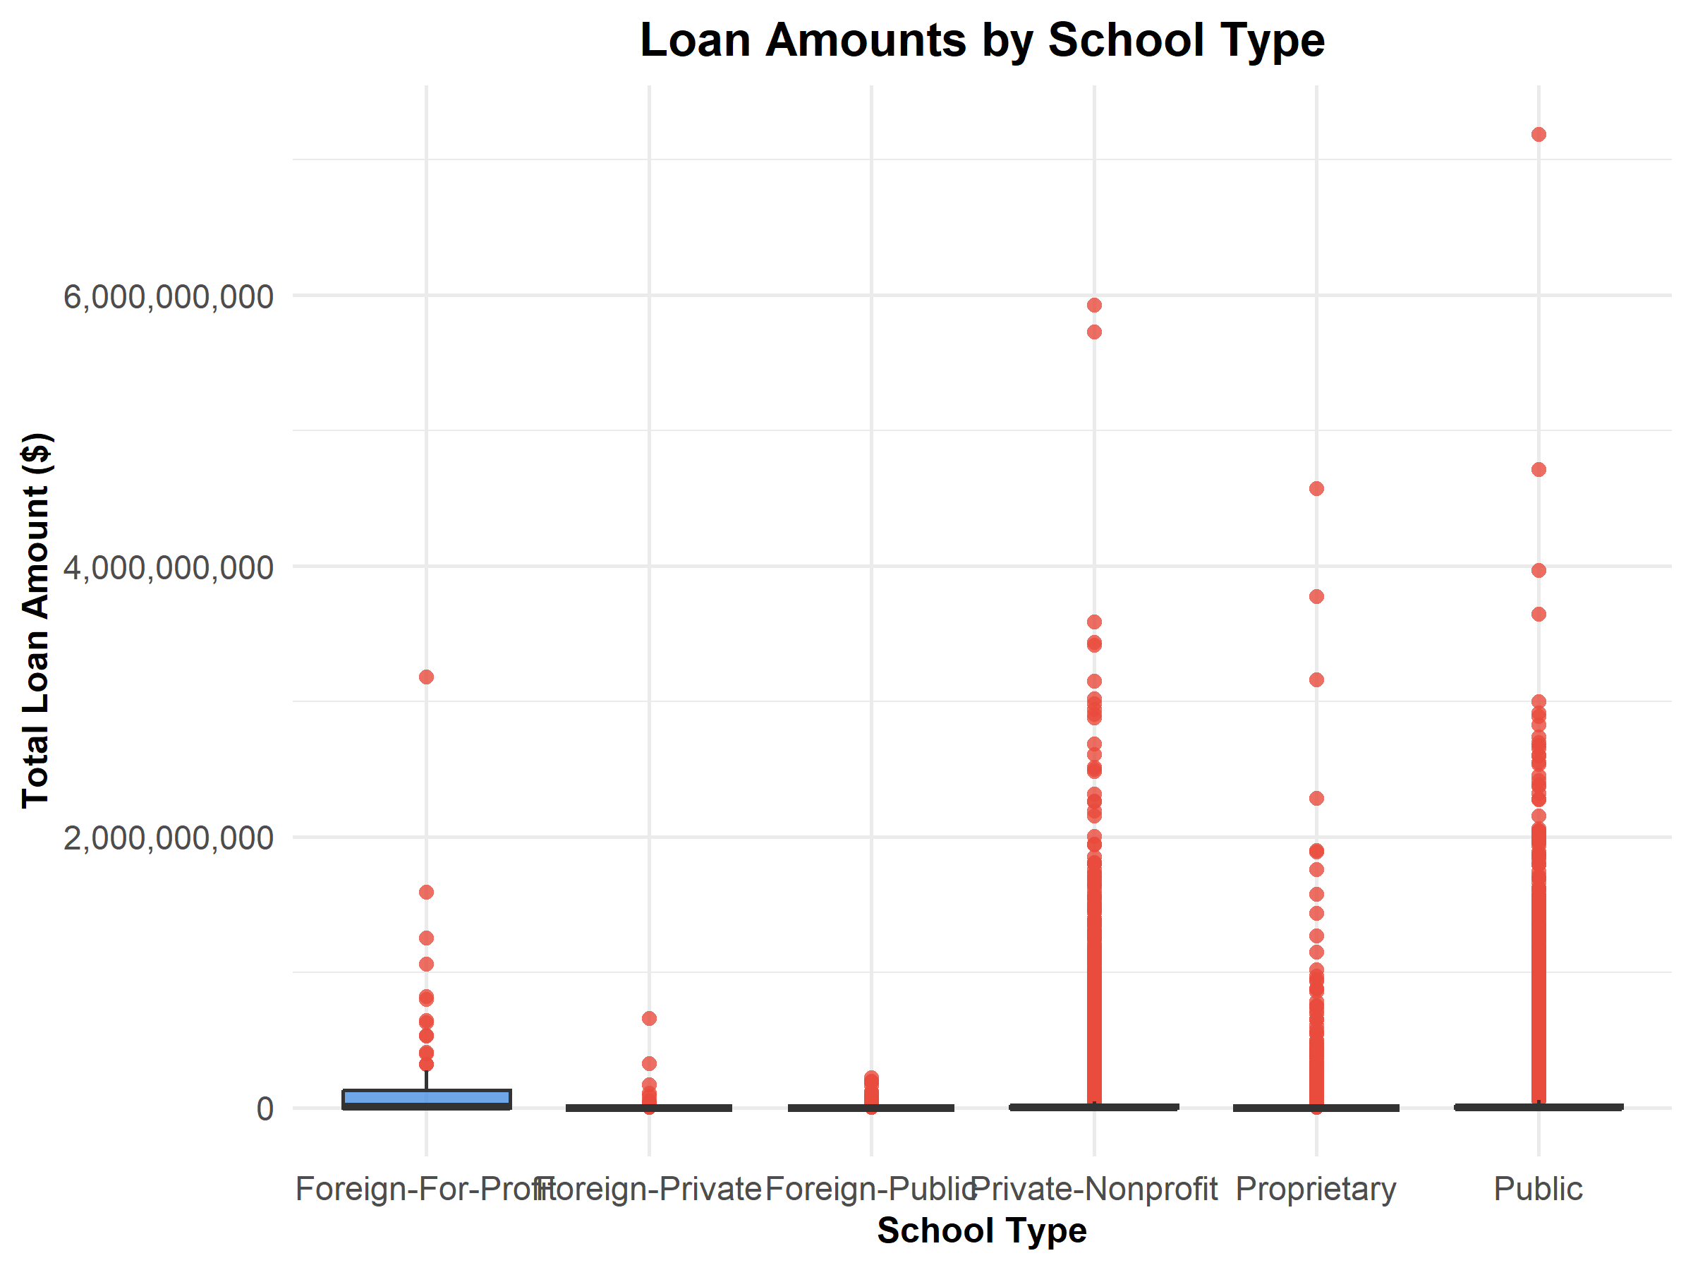
Figure E1

Appendix F – Histogram: Distribution of Total Loan Amounts

Figure F1. Histogram showing the distribution of total loan amounts across institutions.
The histogram displays overall borrowing patterns and the right-skewed distribution of loan
values.

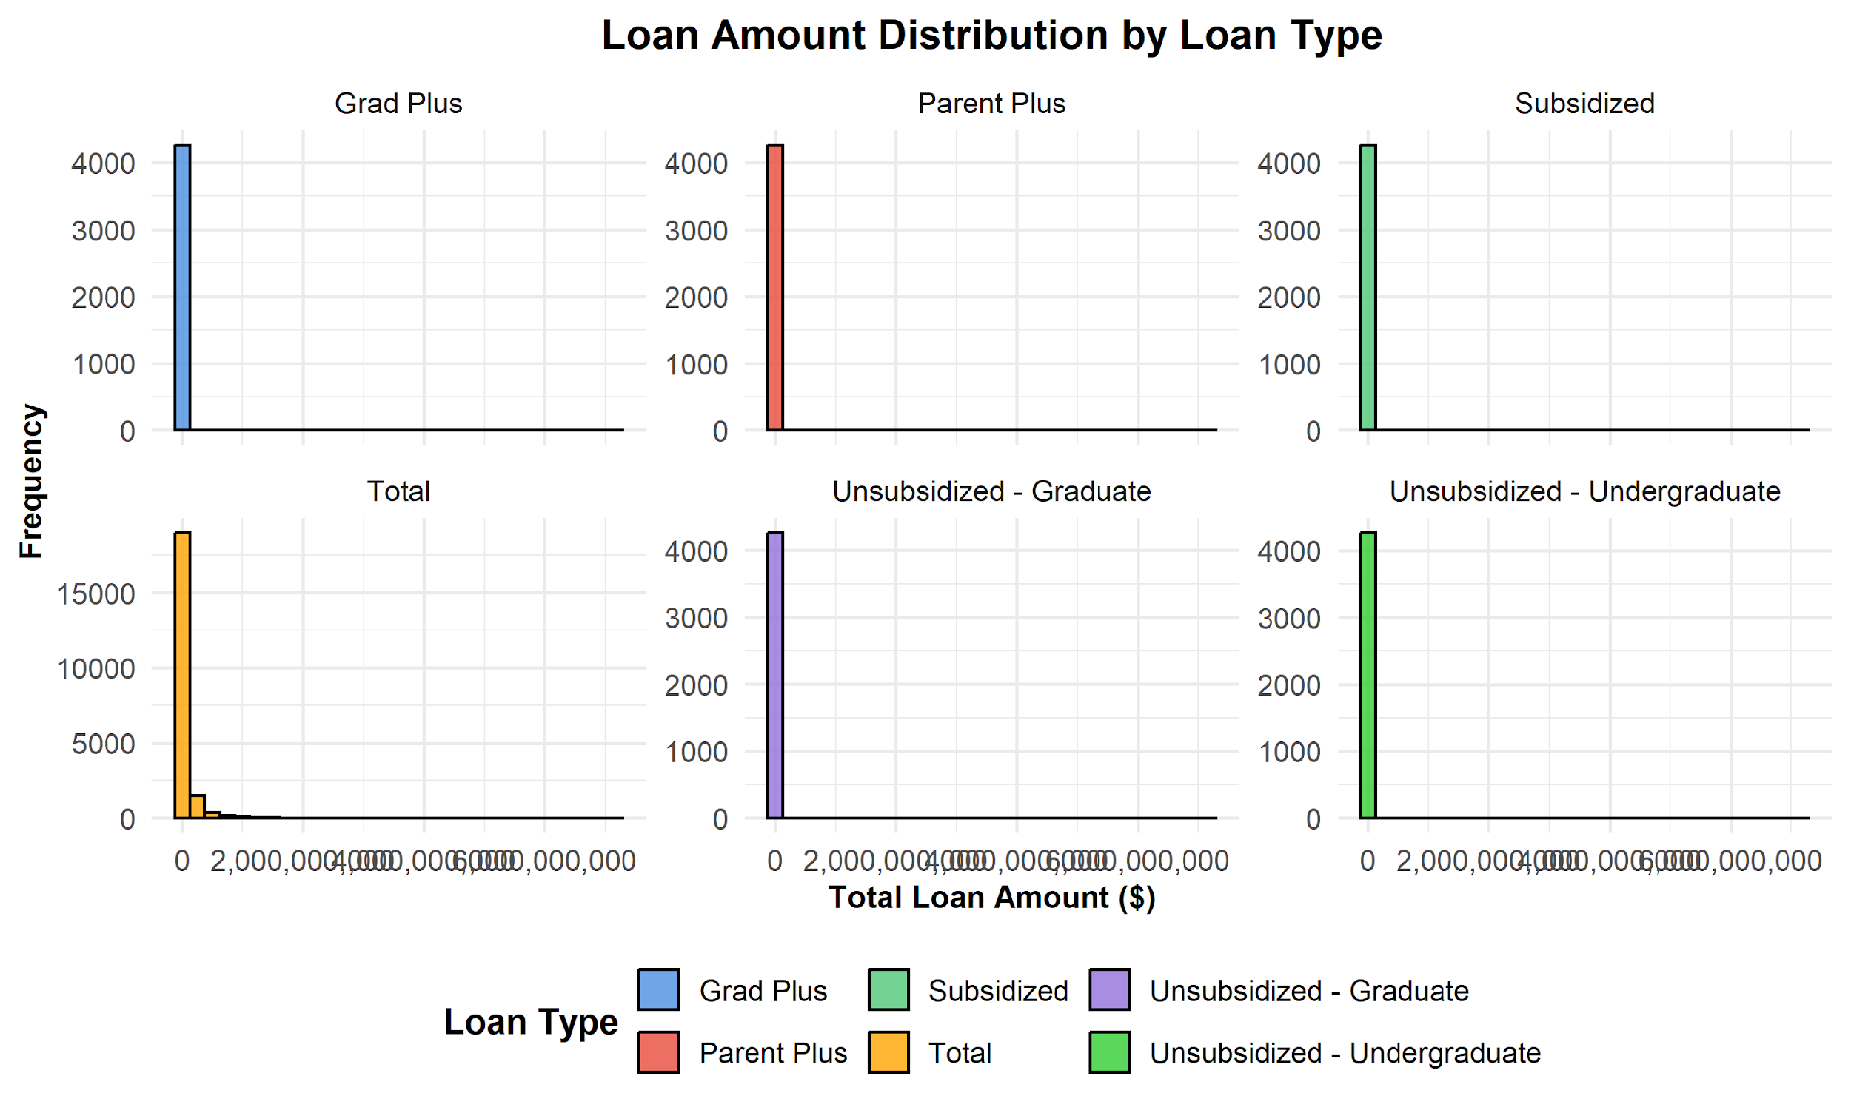
Figure F1

Appendix G – Top Institutions by Total Loan Amount

Figure G1. Bar Plot showing the top schools by total loan amount originated.
This figure highlights how loan volume is concentrated among certain institutions.
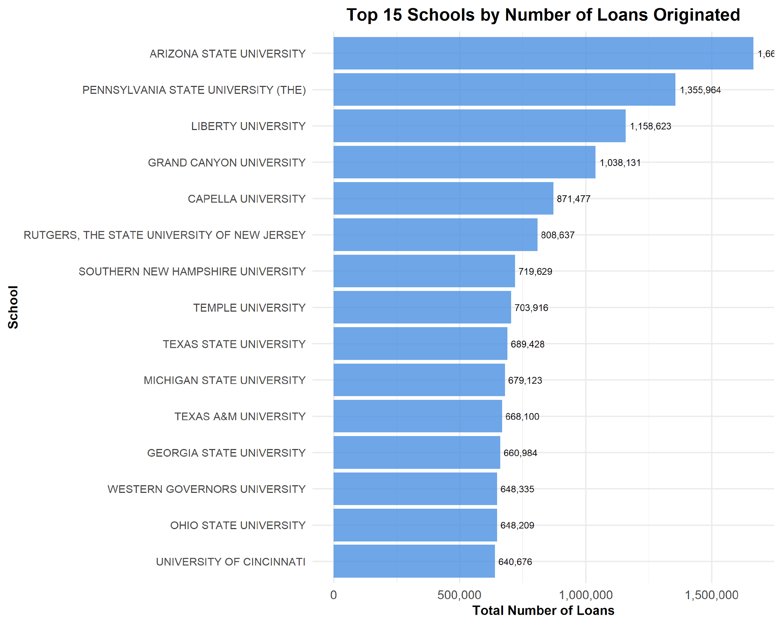
Figure G1

